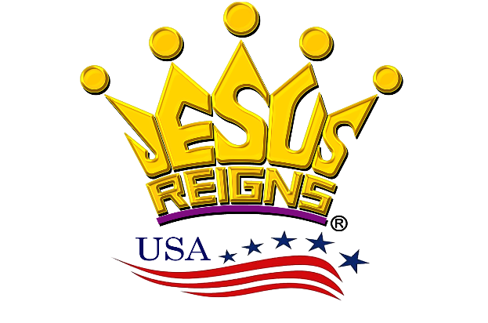  **WORKFLOW**

JESUS

VISION KEEPER

COUNTY /AREAS COORDINATORS

CITIES COORDINATOR

CITIES COORDINATOR

CITIES COORDINATORS

CITIES COORDINATORS

CITIES COORDINATORS

COUNTY /AREAS COORDINATORS

COUNTY /AREAS COORDINATORS

COUNTY /AREAS COORDINATORS

COUNTY /AREAS COORDINATORS

STATES COORDINATORS

STATES COORDINATORS

STATES COORDINATORS

CENTRAL TIME ZONE COOR

STATES COORDINATOR

STATES COORDINATORS

EASTERN TIME ZONE COOR

MOUNTAIN TIME ZONE COOR

PACIFIC TIME ZONE COOR

HAWAII / ALASKA REGION COOR

NATIONAL CORE TEAM

USA MAINLAND COORDINATOR