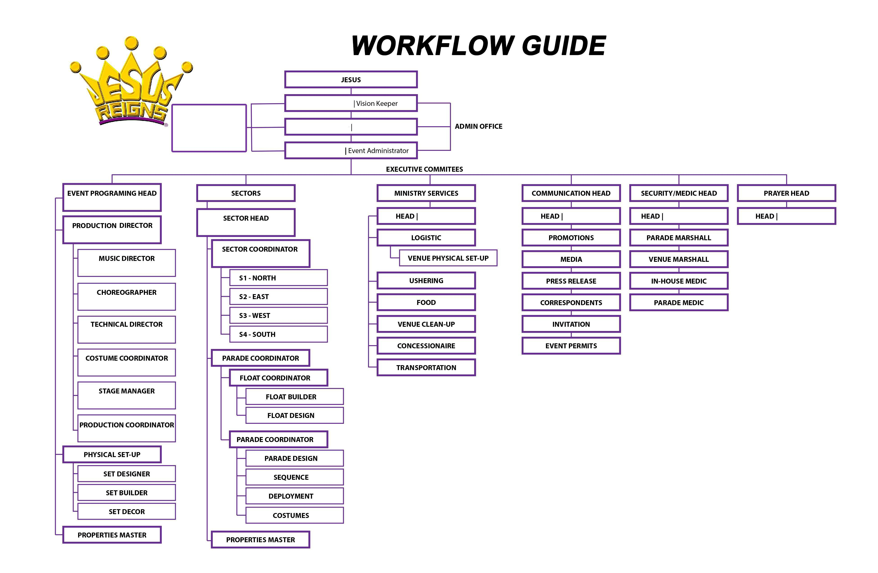 **WORKFLOW GUIDE**

**E**

CITY COORDINATOR